Customer 360 and Next Best Action Engine

Developers need to build a solution for insurers and lenders who struggle with fragmented, siloed customer data across CRMs, ERPs, and support logs. The objective is to unify this data and build an intelligent backend capable of recommending the absolute best single initiative (cross-sell, retention offer, or support intervention) for a customer in real-time.
The requirements of the project are:
1. Problem Brief
- What real business problem does this solve?
- Who is the target user/persona?
- What is the current pain point and how does this improve it?
- Industry/domain context
2. Architecture Diagram
- System design showing data flow
- Which CoCo CLI skills are used and how they connect
- Data sources (structured/unstructured)
- How modular components plug together
3. Impact Statement
- Measurable outcomes (time saved, accuracy improvement, etc.)
- Scalability potential
- How this extends beyond the demo

We have designed the solution for the same which can be understood with the help of the UI snaps and the flow explained. The solution is designed considering the following scenarios:
SCENARIO 1: High-value customers at risk of churn
SCENARIO 2: Cross-sell opportunity — customers with only 1 policy type
SCENARIO 3: Failed / pending payments -> retention risk flag
SCENARIO 4: Claim severity & approval-rate analysis by policy type
SCENARIO 5: Customers with an open/under-review claim AND a recent complaint call
SCENARIO 6: Call transcript keyword scan — find frustrated/at-risk conversations
SCENARIO 7: Full Customer 360 single-view for one customer
SCENARIO 8: Policy lapses / cancellations by state & segment
SCENARIO 9: Channel effectiveness — which channels correlate with more claims/complaints
SCENARIO 10: Composite "Next Best Action" candidate list
The Architectural design of the Intelligence layer consists of the following:
- Retrieval: Pull the unified customer profile alongside a repository of active "actions" (e.g., Offer Loan Top-Up, Send Churn Retention Discount, Escalate Support Ticket).
- Eligibility & Business Rules: Filter out actions the customer doesn't qualify for (e.g., do not offer a premium credit card if their credit score is below a strict threshold).
- Predictive Ranking: Use Machine Learning or fine-tuned LLM scoring to sort the remaining actions based on the highest conversion probability or risk-mitigation value.
- Explainability Gate: Provide a clear "reasoning" output for sales or support agents explaining why this specific action was recommended
The UI consists of the following modules, and each are explained in short along with the visual of how the app is designed in a user-friendly interface.
Page 1 which is the command center provides one unified view of all the data points that are to be considered for the unified customer view. It does not provide any interactive controls and is a visual representation of the base data points.
Page 2 is the Customer 360 page which can be used by the insurers or lenders to get one view of their customer records and the NBA (Next Best Action) suggested. The NBA can directly be sent as an email from the same page. The below options are given as interactive filters which allow filtering for the customers
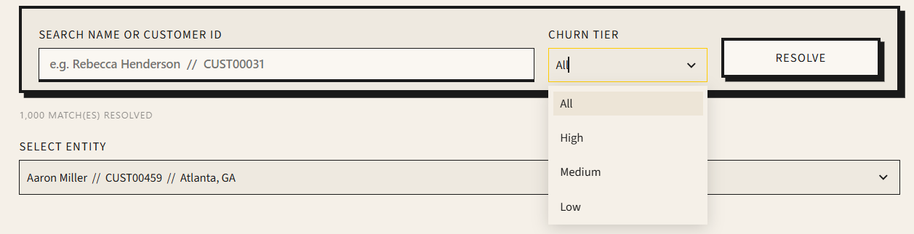

The operator can review the script generated and if needed to regenerate it, can hit the regenerate script button to get an alternative way to rephrase the sentence. For this script generation, we have used the Cortex Complete function. Once satisfied with the text generated, can click on Dispatch Email and the email is received by the customer.
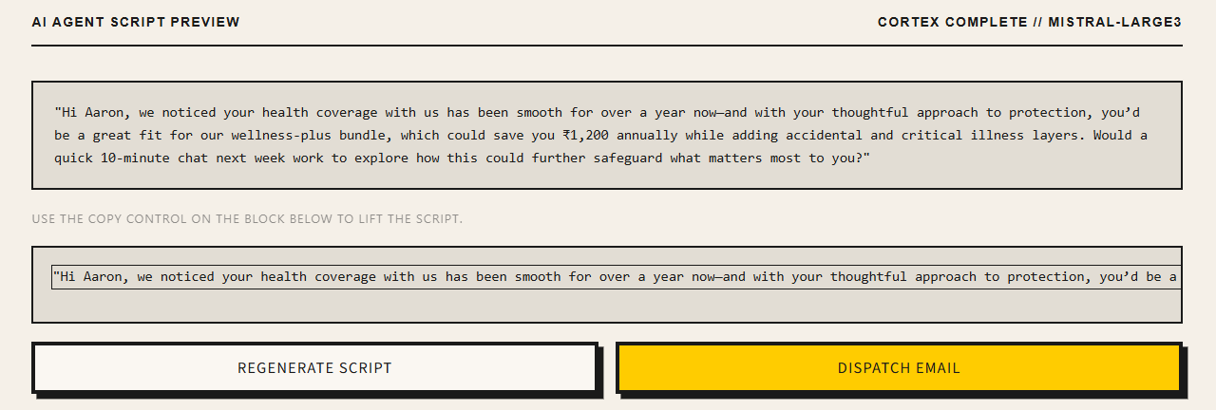

Sample email generated is as given below. The first email snap is internal email that is kept with the operator for record keeping while the second email snap show the actual email received by the customer.
Internal Email:
Insurance 360 | Medium Priority

Internal Team Copy — Do Not Forward to Customer

Customer Profile
Aaron Miller
CUST00459 • Atlanta, GA • Mass Affluent
14.0%  Churn Risk | 34%  Upsell | ₹4,405  LTV | +0.00  Sentiment

Email
nilesh.patil@merkle.com
Income Band
30K-60K
Age
31 (30-44)
Tenure
392 days
Customer Since
2025-09-02
Primary Channel
Email

Signal Decomposition
Active Policies | 1 (1 types)
Total Premium | ₹2,327
Lapsed / Cancelled | 0
Total Claims | 1 (Open: 0)
Failed Payments | 0
Complaints | 1
Avg Sentiment | +0.000

Next Best Action | Email

Cross-sell bundle offer
Single policy type; LTV ₹4404.87 — strong cross-sell candidate

AI-Generated Script — Sent to Customer
Hi Aaron, I noticed your health coverage has been protecting you well for over a year now—great to see! Given your strong history with us, I’d love to share a tailored bundle that could add value to your plan while optimising your ₹4,400+ lifetime value—would you be open to a quick chat this week?

Email to Customer:
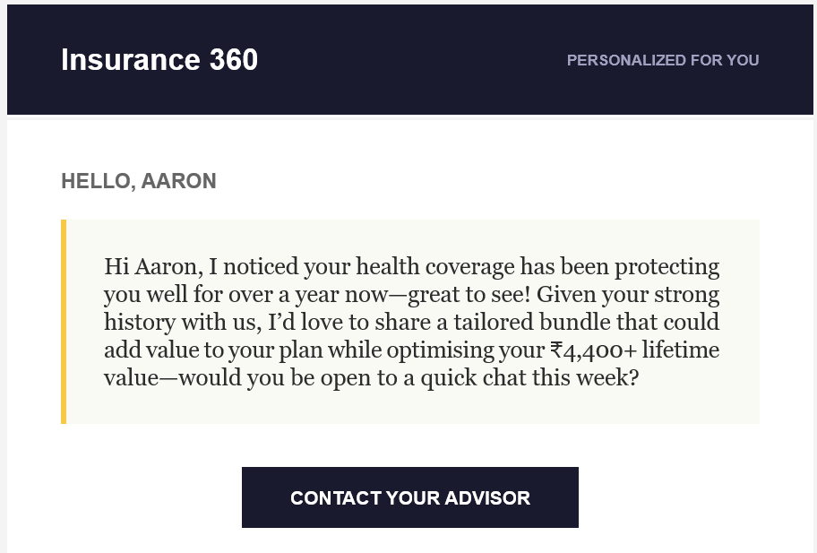

Future Scope of Improvement: Basis the quality of AI generated NBA and textual script over time, these emails can be auto triggered to be sent to customers who need a quick action taken for their respective offers.
Page 3 has the NBA priority Dashboard. Just as mentioned above in the future scope of Improvement, some actions require timely push to the customers and the priority for the next best action is what can be obtained on this page. The following filters are provided to fetch the records of customers that need immediate attention. The priority can be checked and email dispatch can also be triggered from this page.
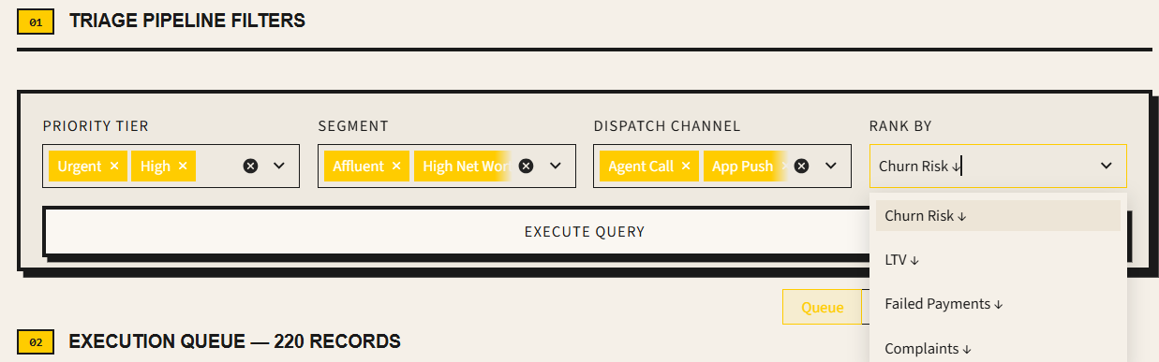
Page 4 shows the analysis of data based on the following categories/types

Page 5 shows the transcript explorer where natural language query can be given by analyst and different data points can be discovered for the transcripts. The scope of filters can be adjusted
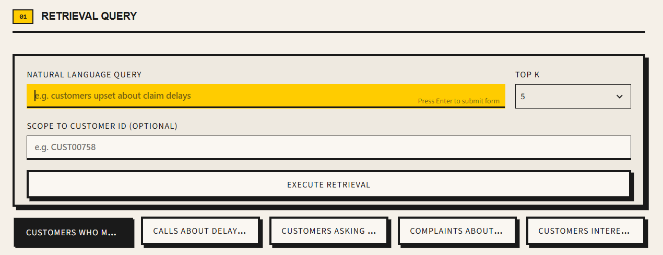
The top N records can be looked at, and some commonly used query points are provided as buttons. The first button for instance is for “Customers who mentioned cancelling their policies” (The label can be adjusted for better visibility going ahead – future scope of improvement)
The Cortex functions AI Transcribe, AI Classify, Search preview, AI_Complete, Sentiment analysis and Summarize are used herein.

Page 6 provides more insight by selecting required engine within snowflake and example probing. The transcripts, call records etc. can be analysed as needed. It provides further drill down by the analytics team on different data points. It gives the ability to search the customer records across the entire database.
The Cortex functions used in Page 5 are used here along with the Cortex Agent

Page 7 gives information on the policies, procedures and rule books that need to be referred when determining the NBA. The policy documents applicable and audio recordings of conversations with customer can be investigated.
The Cortex functions AI_PARSE_DOCUMENT, AI_EXTRACT, and AI_TRANSCRIBE (call-recording transcription) are used herein

Page 8 – An entire solution requires operations monitoring once implemented and daily real time transactions, performance points and data can be viewed here.
Based on the previous points mentioned about the future scope of improvement, an important aspect on this page is the Agent accuracy that can be utilized for automating decision-making processes.

